**Galen Framework** is automated testing for **Responsive websites.**

It has its special language **Galen Specs** for describing the positioning and alignment of elements on a Web page.

* **Benefits of Galen Framework**

1. A human-readable language with two variants of syntax (basic and advanced Galen Spec Language).
2. Opportunity to write tests in different languages (Galen Test Suite Syntax, JavaScript, Java API).
3. Detailed HTML-reports.

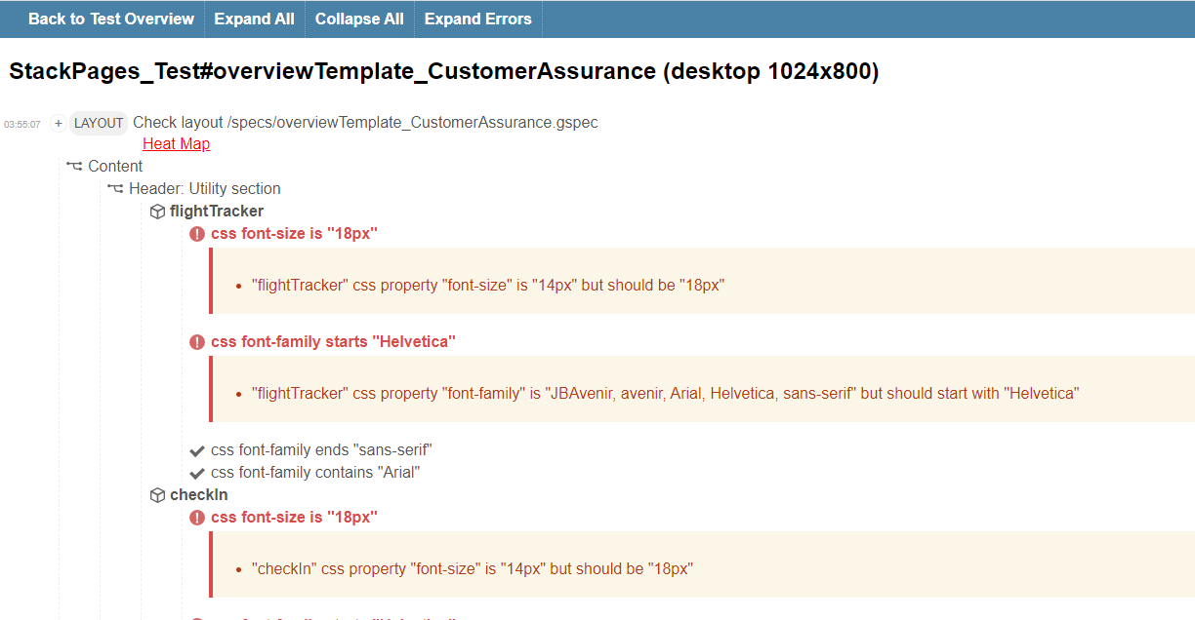

### **Galen Specs Overview**

Galen specs language is very adaptable and gives you the chance to express exactly how you need your website to carry on different devices and different browsers. There are two important parts in page specs file –

1. Object Definition
2. Object Specification
3. **Object definition (Locators: id, CSS, XPath)**

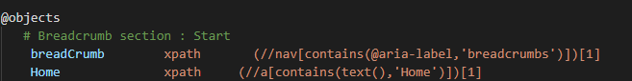

1. **Object Specs Overview (Specifications of the page object) -**

Some of the rules used for Object Specifications: Ranges, Near, Below and Above, Inside, Width and Height, Aligned, Text.

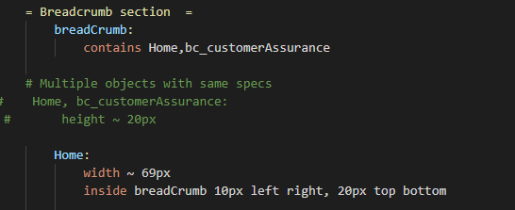

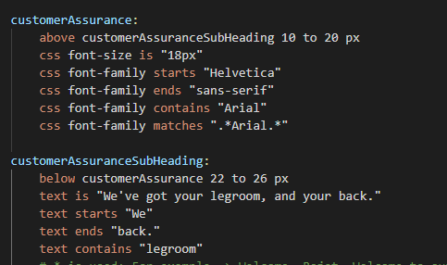

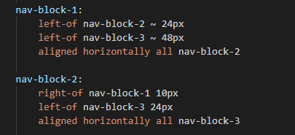

* **Galen has no/limited support for the below:**

1. Changes in the UI (Layout should be pre-defined).
2. **If any of the locators of web elements change, then, script will requires update.**

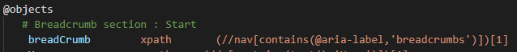

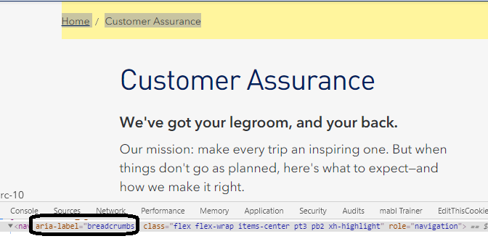

1. Comparison not possible for below conditions:

i) Same environment but, with different release versions **(Ex- Production 1.0 over Production 2.0)**

             ii) Different environments **(Ex- Integration over Production)**